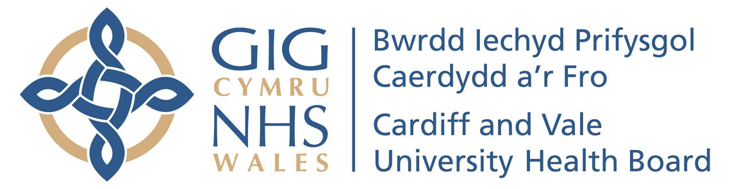
Eich cyf/Your ref:
Ein cyf/Our ref:
Welsh Health Telephone Network:
Direct Line/Llinell uniongychol: 029 2074 8274

University Hospital of Wales
Ysbyty Athrofaol Cymru
Heath Park. Parc Y Mynydd Bychan,
Cardiff, CF14 4XW Caerdydd, CF14 4XW
Phone 029 2074 7747 Ffôn 029 2074 7747

FREQUENT ATTENDERS’ SERVICE
EMERGENCY MEDICINE DIRECTORATE

Address

Dear ………………………,

Notification of Multi-attendance Trigger (Emergency Unit)

Further to my letter of the ……………………………. informing you that future Emergency Unit attendances will be reviewed, it has been noted that you have continued to attend the Emergency Unit a further ---------------- times over the last ----------------------.

Times and dates of attendances and presenting complaints

Over the previous four weeks we have…….

We have implemented a number of steps to support you in order to avoid the need for you to use emergency services. Unfortunately, over the last four weeks, we have not seen an improvement in the number of attendances.

As a result of this, I would like to inform you that we will continue to monitor the situation over the next four weeks and if there is not a reduction in your attendances, consideration will be given to taking further action against you.

Such actions may include:

- Exclusion from the premises
- Providing NHS services at a different location
- Involvement of other external agencies such as the Police.

A copy of this letter will be sent to your GP and any other agencies you may be involved with. You will be contacted by a member of the Frequent Attenders’ Panel following this period of review.

Should you wish to discuss this matter further or feel that we can provide further help and support, please contact the Frequent Attenders’ Service on 029 20748274.

This does not mean that in the event of a genuine emergency, you are unable to access health care in the Emergency Unit.

Yours sincerely,

Frequent Attenders’ Service
Emergency Unit
University Hospital of Wales

