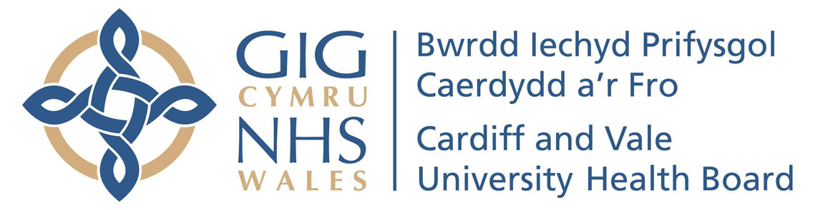
Eich cyf/Your ref:
Ein cyf/Our ref:
Welsh Health Telephone Network:
Direct Line/Llinell uniongychol: 029 2074 8274

University Hospital of Wales
Ysbyty Athrofaol Cymru
Heath Park. Parc Y Mynydd Bychan,
Cardiff, CF14 4XW Caerdydd, CF14 4XW
Phone 029 2074 7747 Ffôn 029 2074 7747

FREQUENT ATTENDERS’ SERVICE
EMERGENCY MEDICINE DIRECTORATE

Address

Dear ………………………,

Notification of Multi-attendance Trigger (Emergency Unit)

We are writing to you as, despite previous correspondence, dated ----------------, and ……. you have continued to attend the Emergency Unit a further ---------------- times over the last ----------------------.

Times and dates of attendances and presenting complaint

You were advised that should we not see a significant improvement in attendances, further action may be taken. This letter is to inform you that we will now be liaising with------------------------, you will receive a letter detailing the outcomes.

Should you wish to discuss this matter further or feel that we can provide further help and support, please contact the Frequent Attenders Service on 029 20748274.

This does not mean that in the event of a genuine emergency, you are unable to access health care in the Emergency Unit.

Yours sincerely,

Frequent Attenders’ Service
Emergency Unit
University Hospital of Wales

