Back Panel Heading

Holistic Support for people living in Cardiff and the Vale

Information leaflet detailing services and support offered to those people who contact Emergency Services on a regular occurrence.
Designed to help reduce calls to the Welsh Ambulance Service/GP OOHS and attendance at the Emergency Department, this service is in collaboration with multi agencies to help promote independence and self care within the population of Cardiff and the Vale

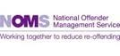

Cardiff and Vale Frequent
Attenders/Callers

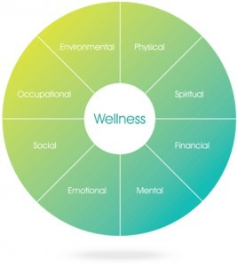

Support for people regularly accessing Emergency Services

Cardiff and Vale Frequent Attender Service c/o Emergency Department University Hospital Of Wales
Cardiff

Phone: 02920 748274

Cardiff and Vale Frequent Attenders Panel

What is the Frequent Attenders Panel?

The Panel consists of a number of agencies from across the Cardiff and Vale area who have come together to provide support for people who regularly use emergency services like the Welsh Ambulance Service, Emergency Department and the GP Out of Hours service.
These agencies are from a wide range of support services and include the Emergency Department, Welsh Ambulance Service, GP/OOHs, Community Projects, Housing Agencies, Neighbourhood Policing Teams, Prison Workers, Probation Services, Age Connect, Mental Health and Substance Misuse Teams, Homeless Services/Nurses, Independent Living Services, the Student Support Services at Cardiff University/Cardiff Met and the Poisons Unit.
These core groups have the ability to refer into other independent services as needed depending on each service users specific needs.
It is recognised that many people regularly calling emergency services have complex issues that could be served better via a multi agency approach, and the panels aim is to facilitate this where necessary.

Why have I been referred?

You have been referred to the Panel due to your increased use of emergency services. This
means that you have contacted services more than 4 times in a 30 day period. This referral is
to enable the Panel to work with you to reduce this number by signposting you to appropriate agencies and support. This intensive course of support will last for X months, during which time, you will be supported by a key worker

What Happens Now?

You will be contacted by a member of the panel, to arrange a meeting/telephone call to discuss your referral. During this meeting/phone call you will have the opportunity to discuss your recent contacts with the emergency services, which will help us to best understand how to support you. You will be asked to sign a consent form in order for us to share your information with the other agencies on the panel, who might be able to offer you their services. An action plan will be drawn up specific to your needs

B

What if I don’t want to be referred?

You have the right to refuse consent, but if you then continue to contact emergency services 4 times a month or more, you may be subject to referral for a civil injunction, and an Appropriate Behaviour Agreement, which will be served in conjunction with the police.

